**Angular HTTP, consuming Rest Services**

In Angular 4.3 the new HttpClientModule has been introduced. This new module is available in package @angular/common/http and a complete re-implementation of the former HttpModule. The new HttpClient service is included in HttpClientModule and can be used to initiate HTTP request and process responses within your application.

HttpClient will use the XMLHttpRequest browser API to execute HTTP request. In order to execute HTTP request of a specific type you can use the following methods which corresponds to HTTP verbs:

* get
* post
* put
* delete
* patch
* head
* jsonp

We Include the Http module into your project in the following way,



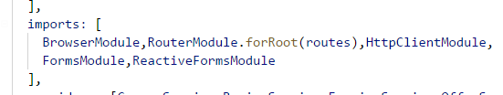

We get the HttpClient service injected in the following way.

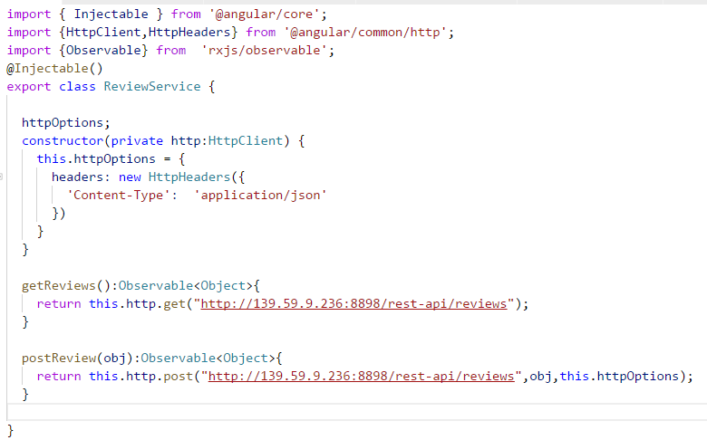

HttpClient.get returns instance of Observable. To display this data either we can subscribe to Observable

In ReactiveX an observer subscribes to an Observable. Then that observer reacts to whatever item or sequence of items the Observable emits. This pattern facilitates concurrent operations because it does not need to block while waiting for the Observable to emit objects, but instead it creates a sentry in the form of an observer that stands ready to react appropriately at whatever future time the Observable does so.

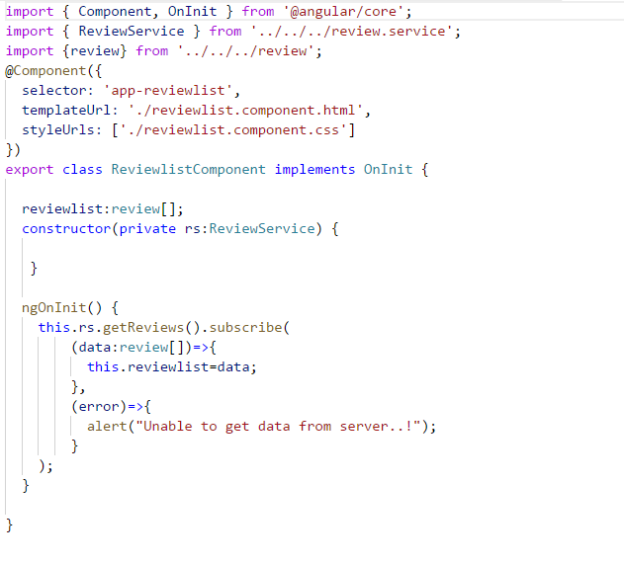

In the above example, review service is injected and we call getReviews() which returns Observable object and we subscribe to it.

And the data is received and stored in the variable review list and in the UI we render it.

